From the PyCitySchools data there were two unexpected trends that should be discussed. The first observable trend was that Charter schools perform much better for % passing math (see output below). For charter schools 93.7% of students pass the math portion, compared to a 66.5% for district schools. For reading the difference is smaller, but still rather large. For charter schools 96.6% of students pass the reading portion, compared to an 80.9% passing rate for district schools. These gaps in math and reading passing percentages translates into less students in the district schools passing overall. For charter schools 90.6% of students pass the overall, compared to an 53.7% passing rate for district schools. Due to these passing percentages I would suggest that parents put forth their best effort to get their child enrolled in a charter school.

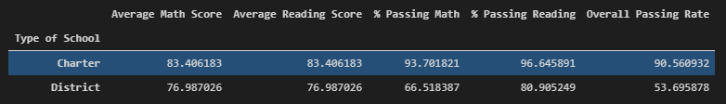

The other surprising data that was discovered is that school size has a large impact on overall passing rates. As can be seen below there is negligible difference between schools that are up to 2,000 students. But once the school becomes larger than that it seems that students passing rates drop off significantly. There is only one charter school (Wilson High School) that is above 2,000 students and the other 7 schools are all district schools. Since this correlates with the previous data that district schools do not perform nearly as well, I would continue to focus on the differences between district and charter schools if trying to determine the biggest impact to overall passing rates.

